OPPORTUNITIES FOR FEDERAL ADVOCACY

- STORIES OF IMPACT: TRUMP ORDERS

- All Massachusetts Congressional Delegates
  - Stories of impacts to individual’s lives; can include success stories. Members can contact their legislators directly (Find contact info. at the bottom of this list).
  - CLM will keep watching out for sign-on letters to flag for Congressional Delegates too.
- Sen. Markey
  - https://www.markey.senate.gov/trumpstories - Senator Markey is fighting back against the orders President Trump has taken that have compromised Americans' access to health care and education, cut off federal funds, canceled research grants, interfered with Americans’ freedom and privacy, and led to thousands of layoffs throughout our federal civilian workforce. His office would like to hear from YOU about how you are being affected.
    - Are you afraid of accessing health care, traveling, going to school, or doing anything else?
    - Have you had trouble getting access to services, like health care, education, or other supports?
    - Have you lost access to health care or benefits that help you pay for food, housing, or other services?
    - Have you been fired or fear being fired by this administration?
    - Have you been expecting federal funds that have either been delayed or denied?
- Rep. Clark
  - https://katherineclark.house.gov/story - “Donald Trump, Elon Musk and Republicans have fired essential civil servants, caused severe disruptions for small businesses and nonprofits, and hurt Americans who count on government services in their day-to-day lives. In many cases the Trump Administration's draconian actions are unconstitutional, and House Democrats are fighting back in Congress and in the courts – however, we need to hear your personal stories so we can fight for you. Please share them below.”
- Rep. Moulton
  - https://moulton.house.gov/address_authentication?form=/services/share-your-story President Trump has taken a number of actions that have compromised Americans’ access to federal benefits, services and funding. Congressman Moulton is fighting back against these orders and would like to hear from YOU about how you are being affected. Congressman Moulton will not publicly share your personal or identifying information without your permission.”

- MORE SPECIFIC CALLS
- Rep. Neal – WESTERN MA (Impacts of Trump Orders)
  - Stories from Western Massachusetts. “Once you all have had a chance to collect data on Western MA and Rep Neal’s district in particular, that would be a great way to augment your MA statewide data. Any anecdotal examples of how Social Security Block Grant (SSBG) funds are supporting Western MA services for children & families will be so useful once we arrive at reconciliation markup.” Sue will email Rep. Neal staff & a HWM staffer.

- Massachusetts Coalition for Coverage & Care - MEDICAID
  - Story Collection Form - Any stories your organization has collected that highlight the importance of Medicaid for the expansion population.
- Center for the American Progress – DOGE
  - Tool from the Center for American Progress mapping Department of Government Efficiency’s (DOGE) funding cuts by congressional district, city, and state
  - Help Us Improve This Tracker - “Do you need more information about DOGE’s harms? Is there something missing from this tracker? If you have feedback, we want to hear from you. Our goal is to provide you with up-to-date data and facts on how funding cuts from DOGE and the Trump administration are affecting your community.”

- Sen. Warren – SCHOOLS
  - https://www.warren.senate.gov/save-our-schools - If you have a favorite memory from public school, you could only go to school because you got financial aid, or you have any story that can remind people why we need to save these programs, share it now.

ADDITIONAL CONTACT INFO.
Massachusetts US Senators - https://www.senate.gov/states/MA/intro.htm
US Representatives - https://www.house.gov/representatives
District | Member  (Residence) | District map | Website Contact Form
1st | 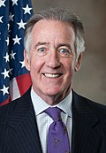  Richard Neal  (Springfield) | 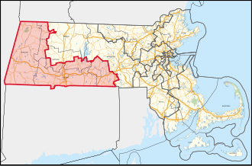 | https://neal.house.gov/contact/contactform.htm
2nd | 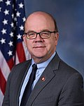  Jim McGovern  (Worcester) | 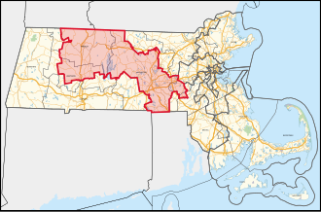 | https://mcgovern.house.gov/contact/zip-auth.htm
3rd | 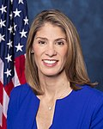  Lori Trahan  (Westford) | 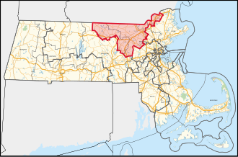 | https://trahan.house.gov/contact/write-your-rep.htm
4th | 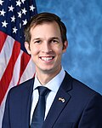  Jake Auchincloss  (Newton) | 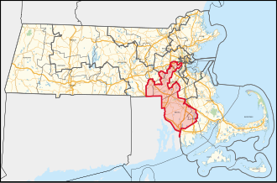 | https://auchincloss.house.gov/contact/emailme?1
5th | 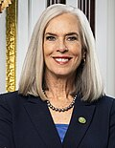  Katherine Clark  (Revere) | 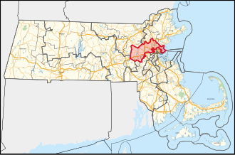 | https://katherineclark.house.gov/story
6th | 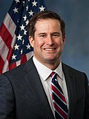  Seth Moulton  (Salem) | 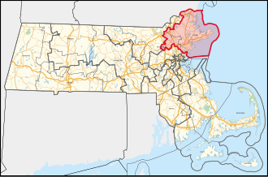 | https://moulton.house.gov/address_authentication?form=/services/share-your-story
7th | 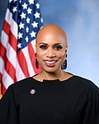  Ayanna Pressley  (Boston) | 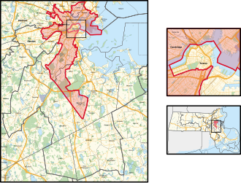 | https://pressley.house.gov/contact-us/
8th | 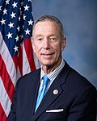  Stephen Lynch  (South Boston) | 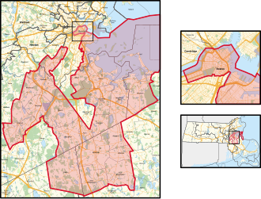 | https://lynch.house.gov/email-me
9th | 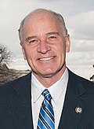  Bill Keating  (Bourne) | 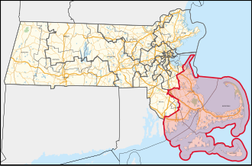 | https://keating.house.gov/zip_authentication?form=/contact

